RIMSS
Architecture Diagrams
Nagarro Software Pvt. Ltd.
Microsoft Architecture Group

Revision History
Version | Date | Author/Contributor | Comments
1.00 | 2026-10-21 | Zibran Shaikh | Consolidated architecture diagrams

Contents

1. Introduction
This document gathers all RIMSS architecture diagrams in one place. Decisions behind them are recorded in docs/adr and the editable Mermaid versions are in docs/ARCHITECTURE.md.
- rimss-app: React 19 PWA with a plugin-based module registry.
- rimss-api: Express API with injected repositories (PostgreSQL or JSON/in-memory).
- @rimss/shared: types and zod request schemas used by both.

2. Technical Diagram
End-to-end view from browsers through the CDN-served SPA to the API and backing services.
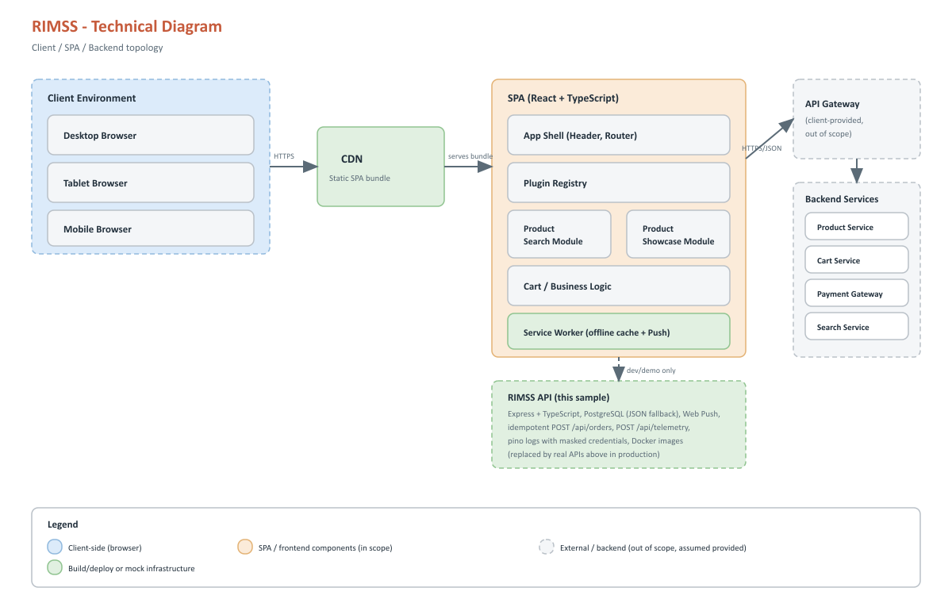
Client, SPA and backend topology

3. System Architecture
Layered view of the application and its runtime dependencies.
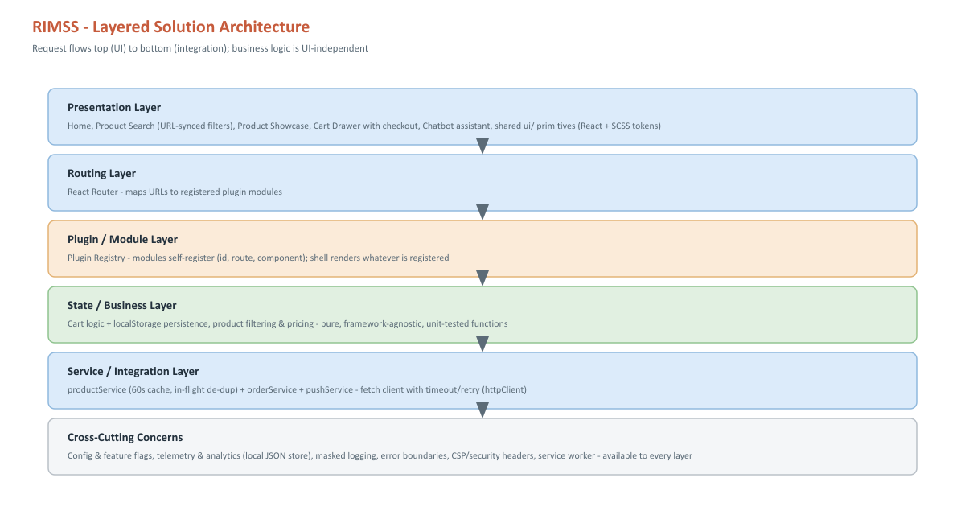
System architecture

4. System Model
Main actors, capabilities and their relationships.
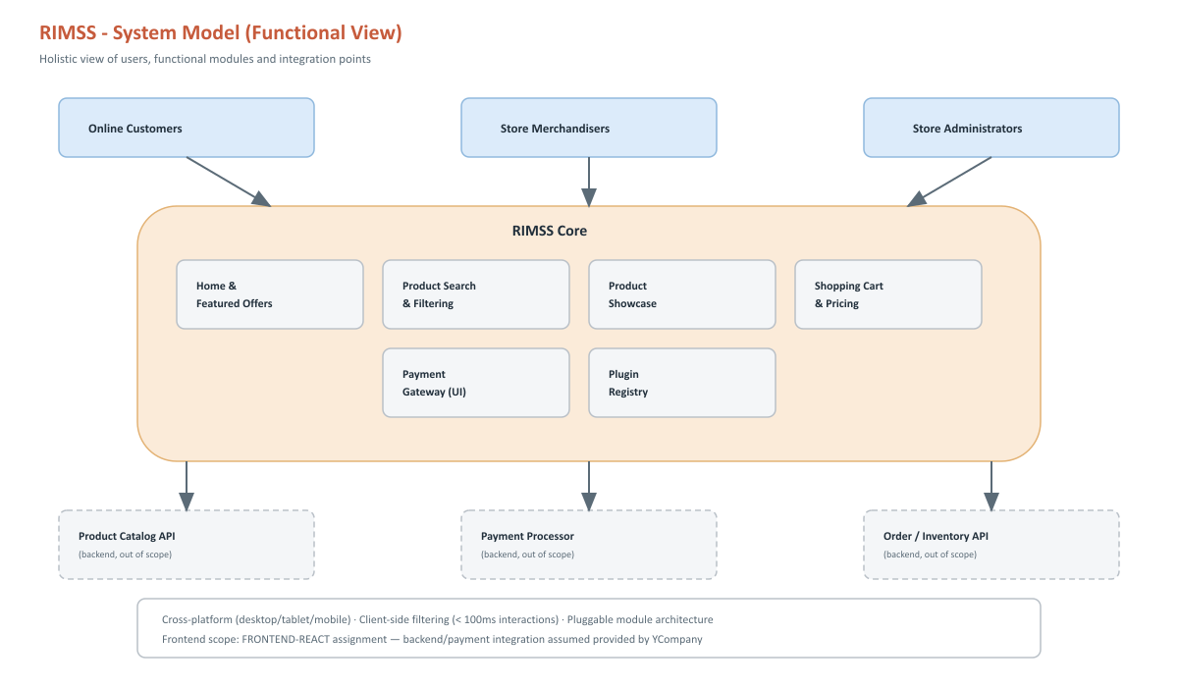
System model

5. Frontend Component Architecture
Plugin registry, feature modules and shared layers (ADR 0001).
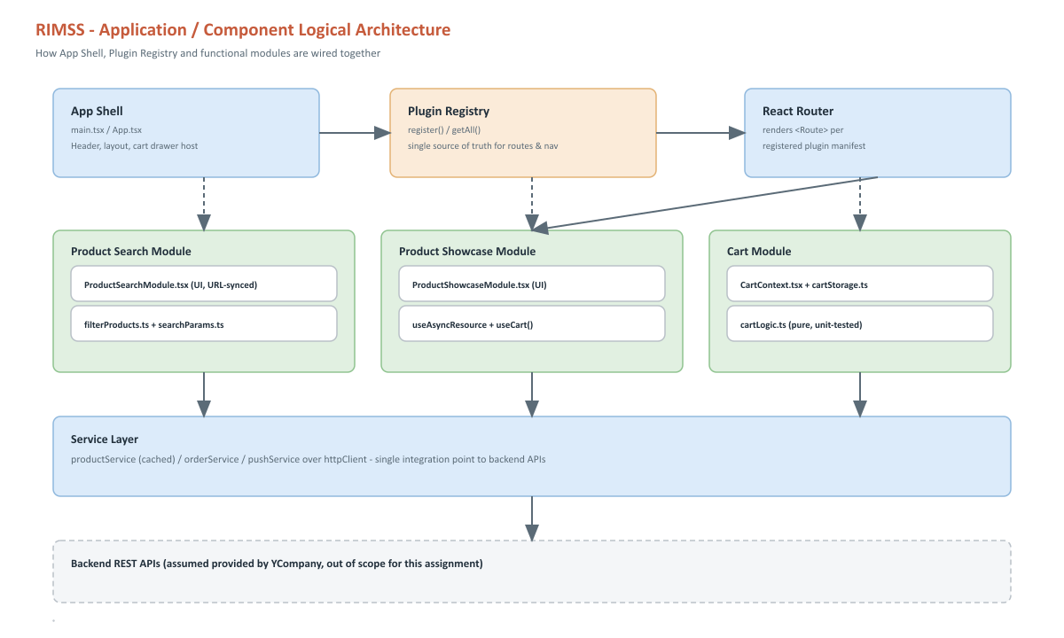
Frontend component architecture

6. API Architecture
Composition root, routers and injected repositories (ADR 0002).
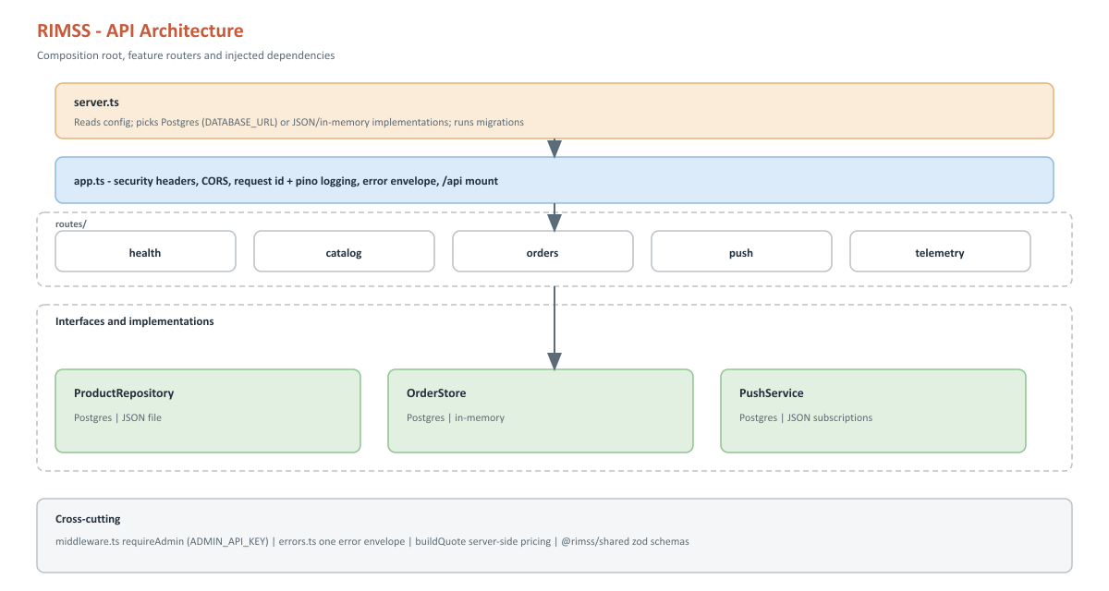
API architecture

7. Data Flow
How catalog and cart data move between UI, services and API.
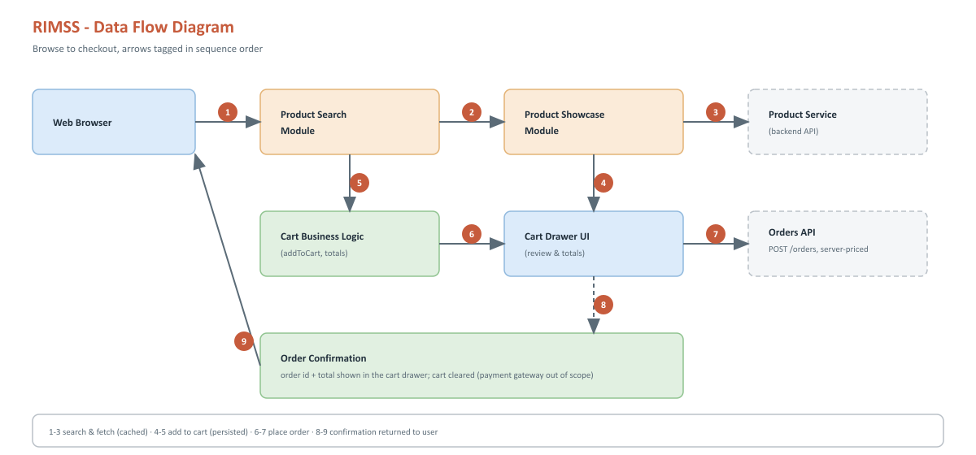
Data flow

8. Checkout Sequence
Server-side pricing, sign-in at checkout, idempotent order creation and stock reservation (ADR 0004, 0010, 0011).
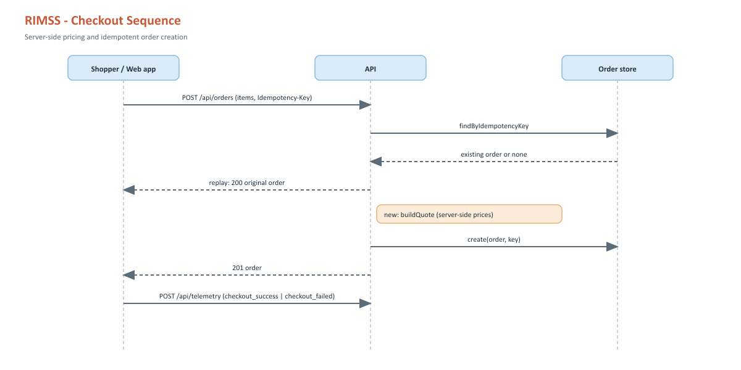
Checkout sequence

9. Web Push Sequence
Subscription and admin broadcast with VAPID (ADR 0006).
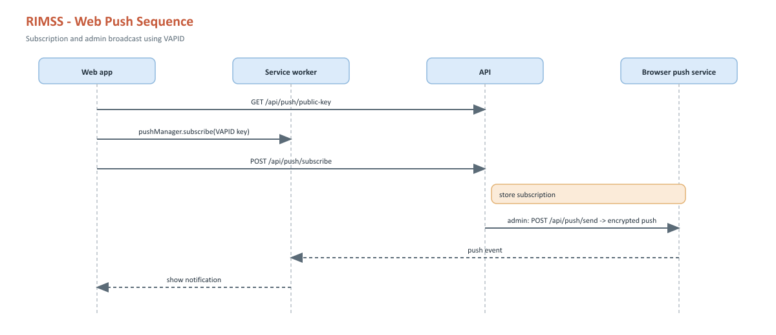
Web Push sequence

10. Repository and Folder Structure
Turborepo layout of the app, API and shared package.
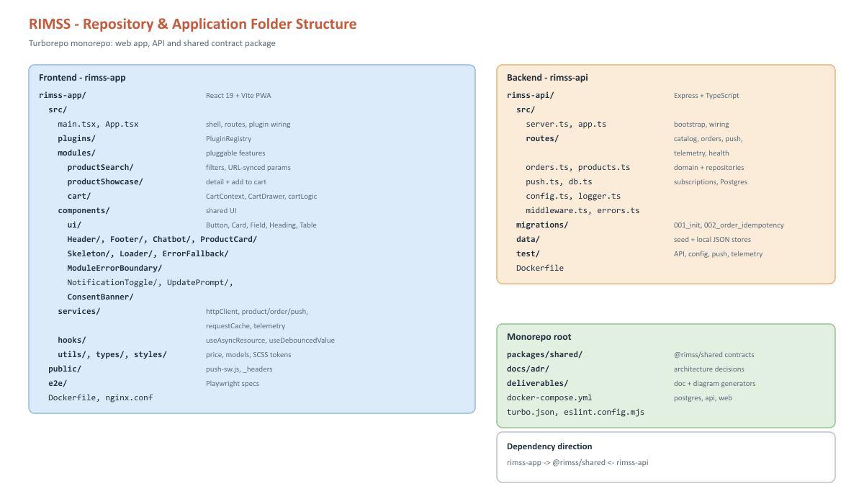
Repository and application folder structure

